

HIMALAYA COLLEGE OF ENGINEERING

**Advanced C++ Programming Lab Report**Lab 1: Quadratic Equations, Triangle Classification and Password Strength Checking

**Prepared By:** Krrish Nyoupane

**Subject:** Object Oriented Programming (OOP)

**Program:** Bachelors of Electronics and Computer Engineering

**Institution:** Himalaya College of Engineering  
**Date:** May 25, 2025

**Objectives:**

* To utilize control structures, functions, and built-in libraries in C++ programming.
* To perform calculations involving quadratic equations using the standard formula.
* To implement logic that checks if a triangle is valid and determines its type.
* To use string manipulation and character analysis for evaluating password strength.

**Tools and Libraries Used:**

* Programming Language: C++
* IDE: G++
* Libraries: **#include <iostream>, include <string>, #include <math>**

**Theory:**

**Basics of C++ Programming**

C++ is a versatile language used to build efficient programs. Beginners start by learning variables, conditional statements, and loops to solve simple problems.

**Structure of a C++ Program**

A basic C++ program includes header files (like **<iostream>**) and starts with **main()**, which is the entry point. The program uses **using namespace std;** to access standard features easily. The main function contains the code and ends with **return 0;** to indicate success.

Example:

1. #include<iostream>
2. using namespace std;
3. int main() {
4. cout << "Hello world!";
5. return 0;
6. }

**Variables and Data Types**

Variables store data. You can declare and assign them like this:

1. int age; // Declaration
2. age = 20; // Assignment
3. int score = 100; // Declaration + Initialization

**Common Data Types:**

* int – whole numbers (e.g., int x = 5;)
* float – decimal numbers (e.g., float pi = 3.14;)
* double – more precise decimals (e.g., double d = 2.718;)
* char – single characters (e.g., char c = 'A';)

**Variable Naming Rules**

* Start with a letter or underscore
* No digits at the beginning
* No space or special characters (except _)
* Case-sensitive (Age ≠ age)

**Conditional Statements**

Conditional statements control program flow based on conditions.

**if statement:**

Used when we must check the condition.

Syntax:

* 1. if (condition) {
  2. // Code runs if condition is true
  3. }

**if...else statement:**

Used when we must check the condition and execute true and false condition separately.

Syntax:

1. if (condition) {
2. // Runs if true
3. } else {
4. // Runs if false
5. }

**else….if ladder:**

Used when multiple conditions are to be checked one after another.

Syntax:

1. if (condition1) {
2. // code if condition1 is true
3. } else if (condition2) {
4. // code if condition2 is true
5. } else if (condition3) {
6. // code if condition3 is true
7. } else {
8. // code if none are true
9. }

**switch Statement:**

Used to select one block of code from many options based on a variable's value.

Syntax:

1. switch (expression) {
2. case value1:
3. // code for case 1
4. break;
5. case value2:
6. // code for case 2
7. break;
8. ...
9. default:
10. // code if no cases match
11. }

**Loops in C++**

**for Loop**

Used when the number of iterations is known.

Syntax:

1. for (initialization; condition; update) {
2. // code to repeat
3. }

**while Loop**

Used when the condition is checked before the loop body and the number of repetitions is not fixed.

Syntax:

1. while (condition) {
2. // code to repeat
3. }

**do...while Loop**

Runs the loop body at least once before checking the condition.

Syntax:

1. do {
2. // code to repeat
3. } while (condition);

**Lab Questions:**

**Q no 1:** Solve $a^{2}+bx+c=0$ and handle all discriminant cases.

Code:

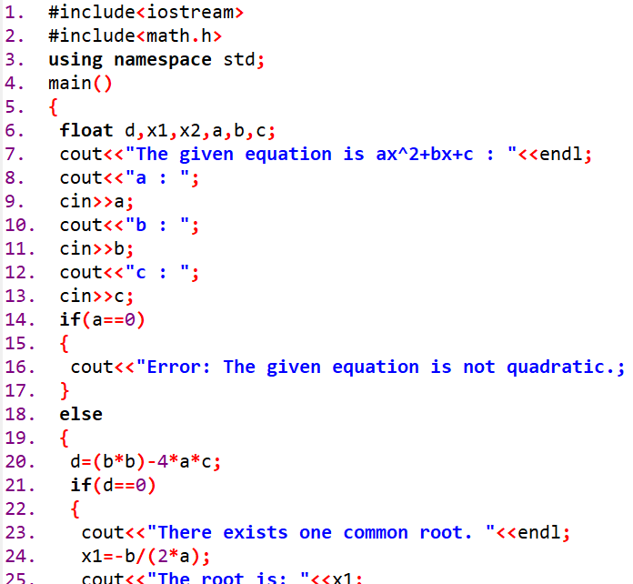

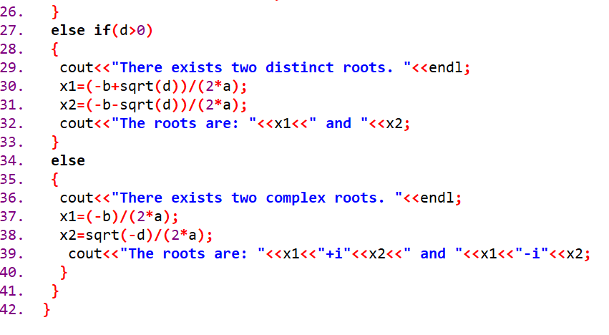

Output:

**Q no 2:** Check if three angles form a triangle and classify it.

Code:

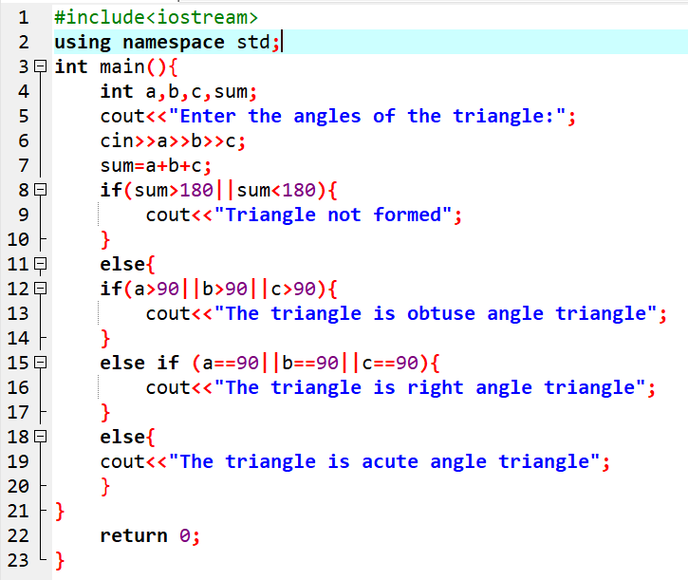

Output:

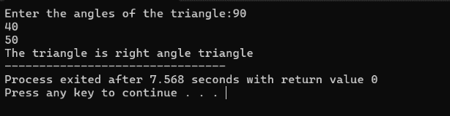

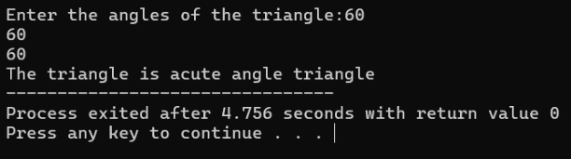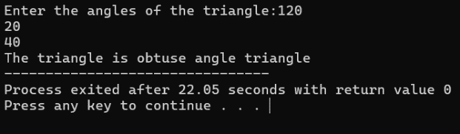

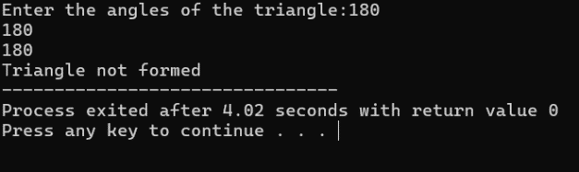

**Q no 3:** Check password strength based on length and character rules.

Code:

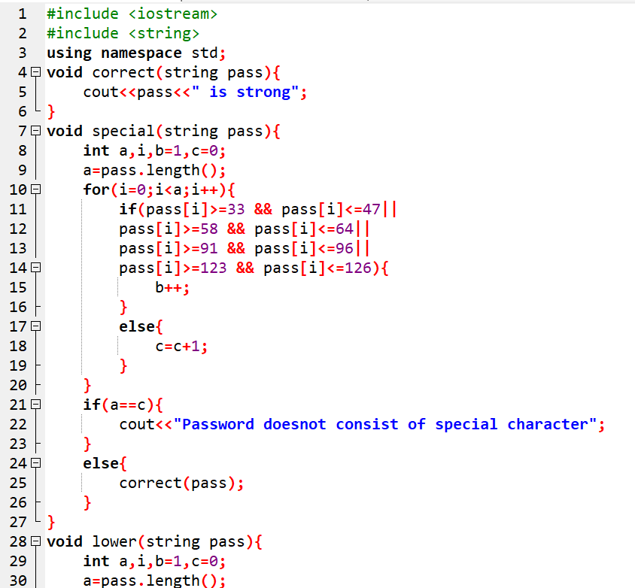

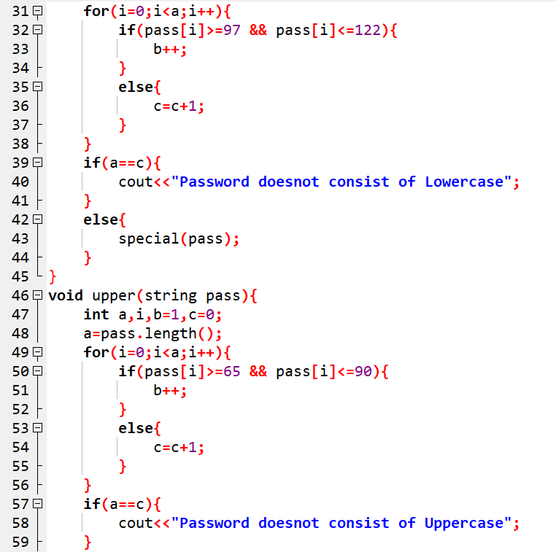

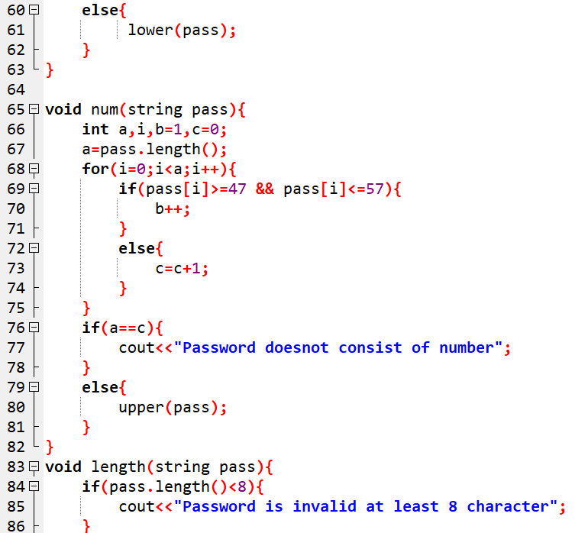

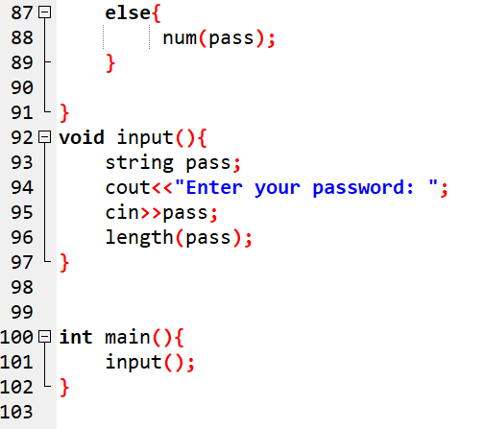

Output:



**Conclusion:**

In this lab, we explored essential C++ concepts by tackling various practical problems. The focus was on utilizing control structures, functions, and string manipulation methods. This practical approach lays a strong foundation for progressing to more advanced subjects, such as C++ development and object-oriented programming.